Gas Pressure and Temperature Relationships

Name________________________________ Lab Section___________________________

Log on to the Internet. Type the following address into the location-input line of your browser:

http://cheminfo.chem.ou.edu/~mra/CCLI2004/GLHeNeAr.htm

This will load a Particulate Simulation. Once you have the simulation running your screen will look like what is shown in Figure 1 below. If you haven’t already done so, read the Particulate Simulation section of the Introduction to MoLEs Activities to learn how to use the simulation.
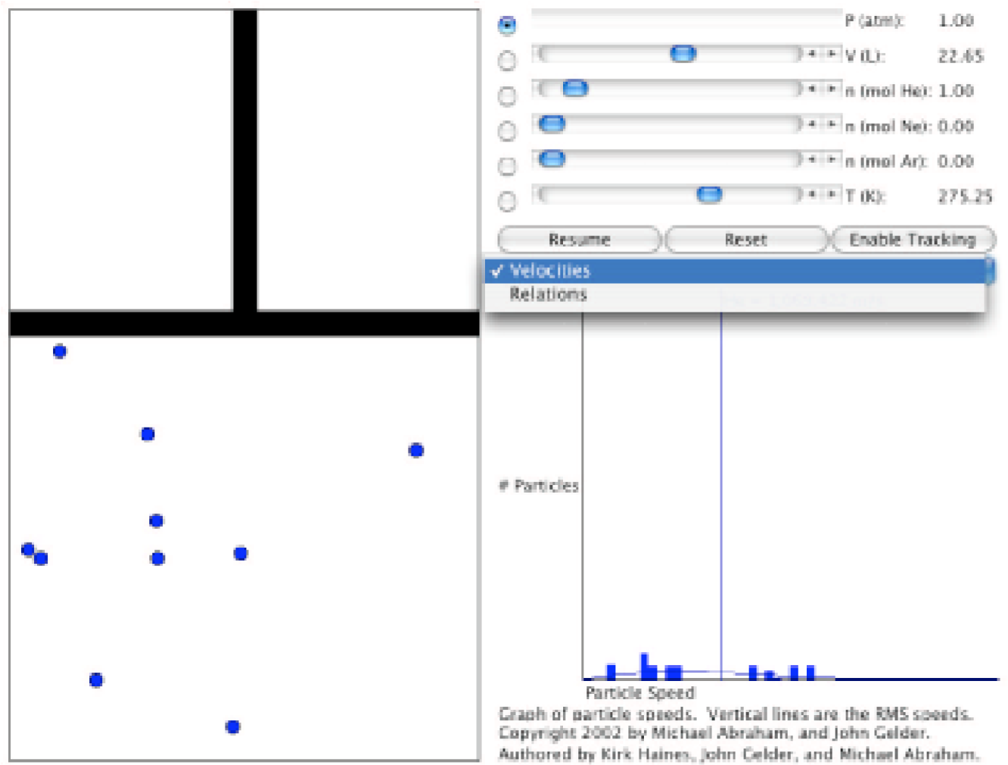
Figure 1.
Problem Statement: How are the pressure and temperature of a gas sample related?

- Data Collection:

  - Open the Gas Law Simulation program and observe and describe, in the space below, the activity in the Gas Sample window. Consider using some or all of the following terms in your description: particles, atoms, molecules, collisions, speed, energy, force.

Atoms or particles tend to move inside the container in straight line motion while colliding other atoms and the wall of the container. Both the speed and direction of the atoms change after collision with other atoms but on colliding the wall, the speed does not change but the direction does. Colliding with other atoms changes the kinetic energy of the atoms/particles. This energy that is produced from the collision of particles is conserved. The pressure that the gas exerts is comes from the force of collision with the wall of the container.

  - One of the objects in the window is colored differently than the others. Enable the tracking function and trace the path of a particle from one side of the screen to the other in the space below. Explain any changes in speed or direction that you observe.

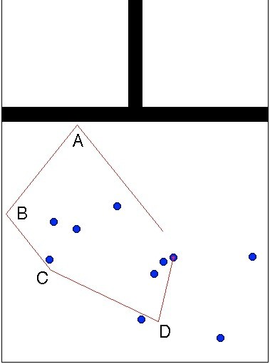
The atom strikes the container’s wall at the point labelled A changing its direction whereas the speed is not altered. The same case happens when the atom strikes the wall at the point labelled B. This means that the speed remains the same before and after collision at both point A and B. Note that point C is not on the wall and so is point D. At point C, both the atom’s speed and direction changes since it collides with a fellow atom. The same happens at point D. However, it is worth noting that the situation at C differs from that at D. This means that the direction that the atom shifts is not symmetric as it is at point A or B. Additionally, the speed change at the two points is very different.

  - Record the values for pressure, volume and temperature on the digital read-outs of the Controls window.
When the reset tab is clicked,
Pressure reads at 1 am/V,
Volume reads 22.65 L,
Temperature reads at 275.25 K, and
1 mole of Helium gas.

  - Observe the action in the Speed Distribution window. Relate what you see with the behavior of the objects in the Gas Sample window.

In the Speed Distribution window, bars represent the different speeds of all the atoms in the sample. Speed changes when atoms collide and so the bars change in height and position along the horizontal axis. A decrease in the height of the bar implies that an atom’s speed has changed, i.e. after collision with another. An increase in height of the bar indicates that the atom’s speed is maintained. The speeds are aligned along the horizontal axis in such a way that an atom’s speed will move from one point to the other after colliding with another atom. For 10 atoms, around 7 – 10 different bars are in place to represent 7 – 10 speeds. This is because as atoms don’t have similar velocities every other time.

Click the Pause button and sketch and label the graph in the space below.
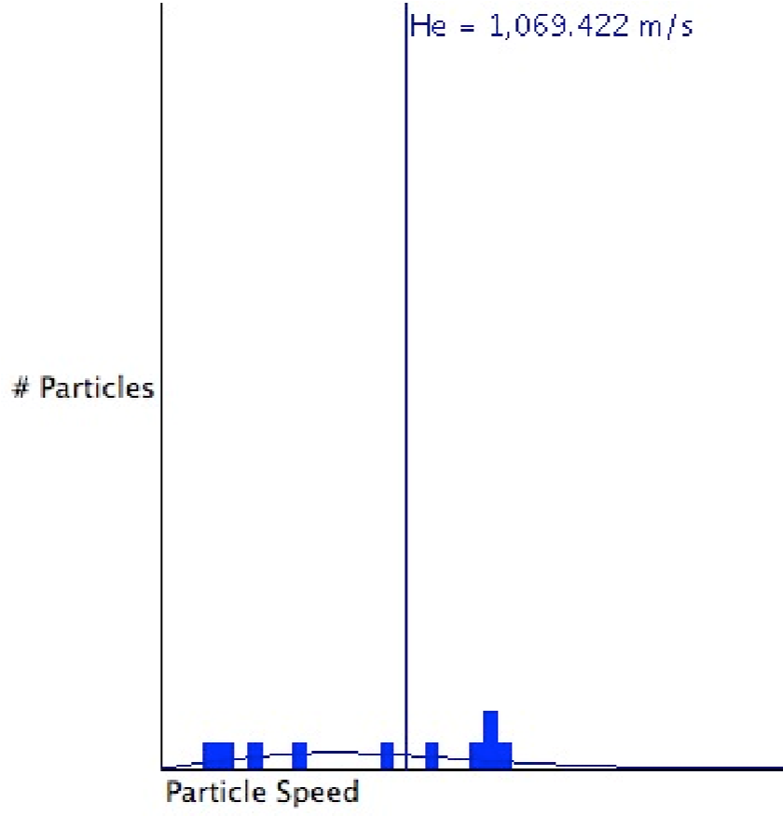
This sketch has 9 different velcoties. On te right side, there is a bar with 2 similar heights. This means that the atoms have similar speeds. Below is another sketch:

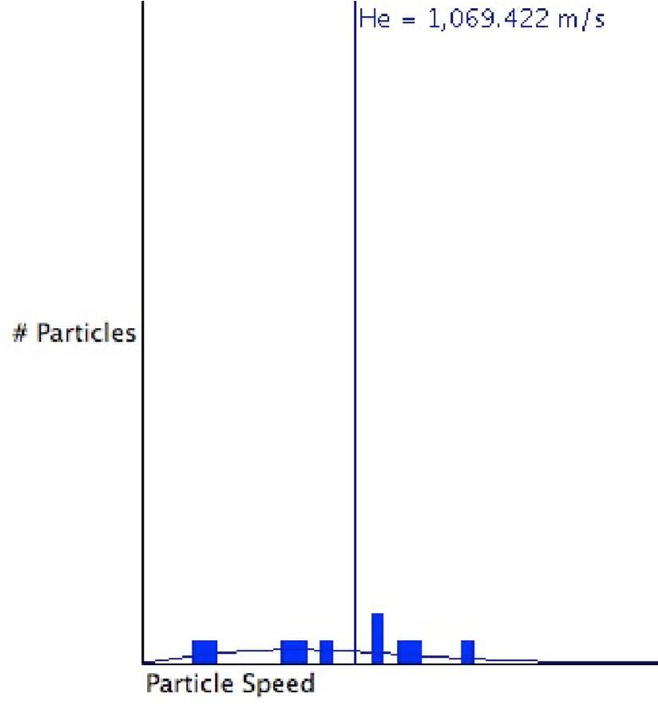

In this sketch, 9 different speeds are seen. They differ at depths as the bars show and as compared to the previous sketch. There are two atoms that have similar speeds.
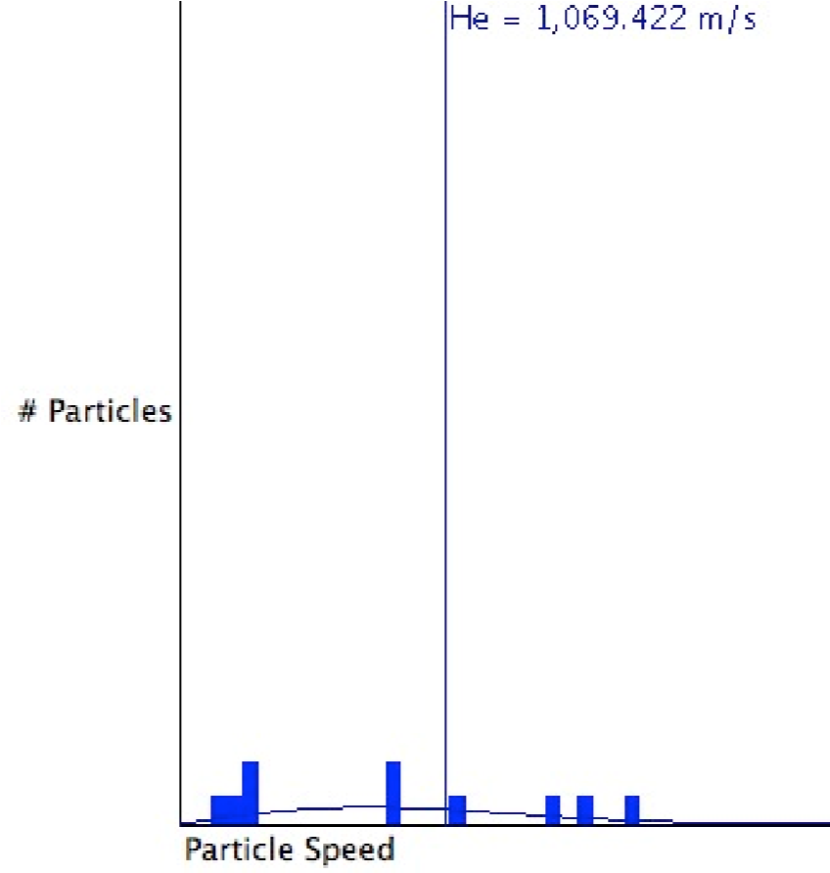
In this sketch, there 8 different bars indicating 8 different speeds.
Observing the Speed window it is true that the bars change constantly an indication that the speeds of the atoms are also constantly changing. Every single change is witnessed after an atoms collides with another. An atom’s speed will remain the same until it collides with another particle.

  - Using the controls in the Control Bar window, change the temperature in the container and observe what happens to the pressure of the system. Also observe what happens in the Speed Distribution window. Explain how the activity in the Gas Sample window accounts for your observations.
When temperature is decreased, the distribution of atom speed in the Speed Window is observed to be much slowly. There is a reduced movement of the bars up & down as well as left & right. This is due the decreased temperature of the container hence reduced the average speed of the collection of atoms to move hence fewer collisions. The atoms move much slowly reducing the collision force of between the atoms and the container’s wall.
As a result, there are fewer collisions with the walls, and much lesser forceful collisions. This results in the observed drop in pressure in the container. Collisions with other particles cause a change in velocity for each particle we observe that the distribution of velocity changes more slowly. Since the particles are slowing down, the number of particles with lower velocity increases, and the number of particles with high velocity decreases, this produces the observed change in the particle distribution and in the observe drop in the average velocity of the collection of particles.

  - Collect five additional observations of pressure/temperature relationships and record all of your data in the following table.

Data Table

Pressure Temperature

0.18 50

0.36 100

0.54 150

0.73 200

0.91 250

1.09 300

1.27 350

- Data Analysis:

What patterns are shown in these data? It might be helpful to graph the data. Try to come up with an algebraic equation that expresses the pattern you found.
This pattern above implies that an increase in temperature increases pressure of the gas. This is a direct or proportionate relationship. A graphical representation is included below.
Summarizing the concept mathematically, we have P/T = Constant given that volume and moles are constants.
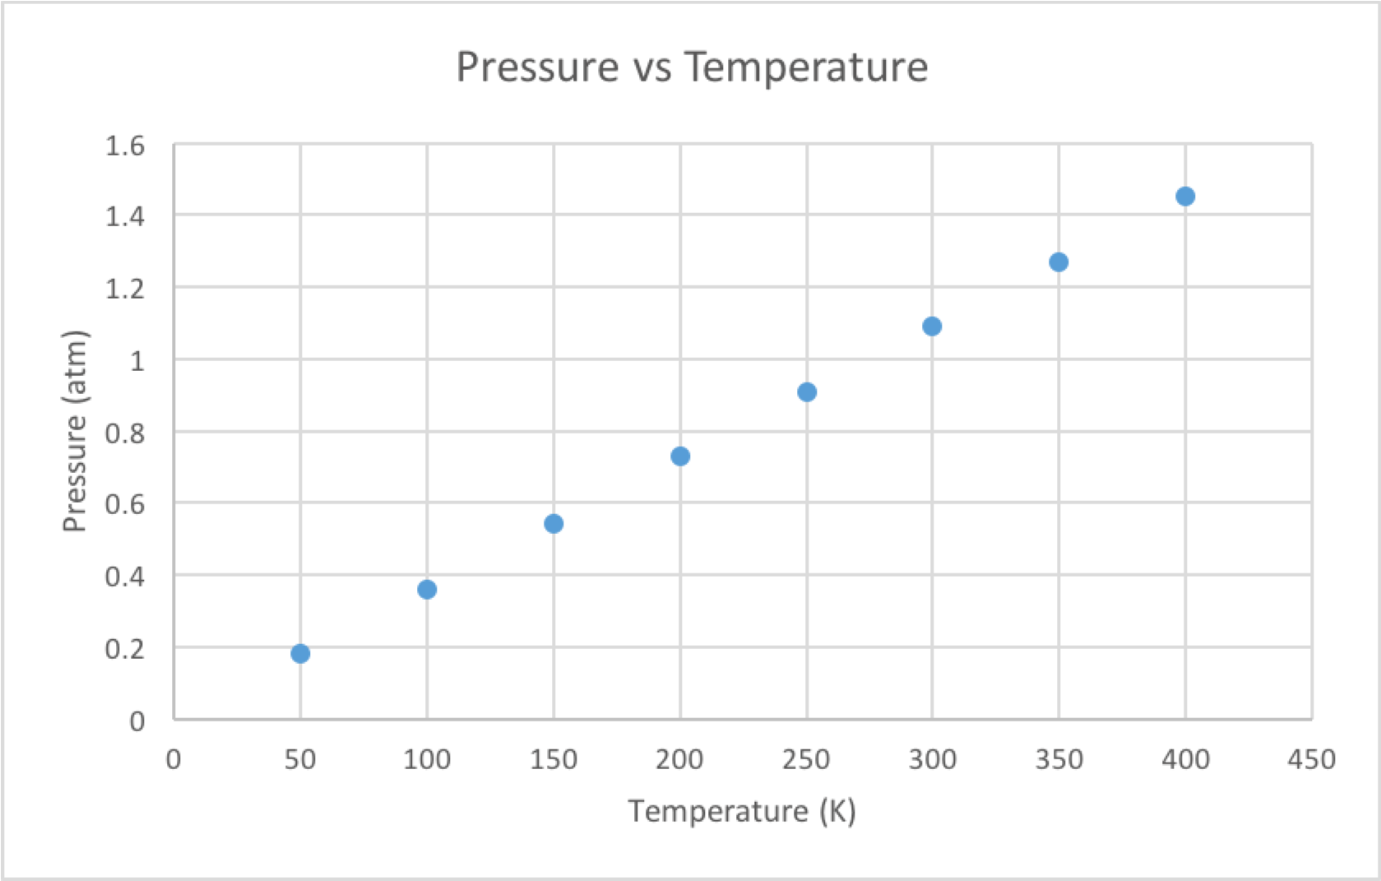

Pressure (atm) | Temperature (K) | P/T  (Constant)
0.18 | 50 | 0.0036
0.36 | 100 | 0.0036
0.54 | 150 | 0.0036
0.73 | 200 | 0.0036
0.91 | 250 | 0.0036
1.09 | 300 | 0.0036
1.27 | 350 | 0.0036
1.45 | 400 | 0.0036

- Interpretation and Conclusions:

  - How are the pressure and temperature of a gas sample related?

Pressure and temperature of a gas are directly related. This means that when the temperature of the container is increased, the pressure increases as well when volume and the moles of the gas are held at constant.

  - Mental Model - Draw a picture(s) that explains how the pressure and temperature of a gas sample are related at the level of atoms and molecules, and that illustrates the observations you made in the experiment. In words, explain how your picture(s) illustrate(s) this relationship.

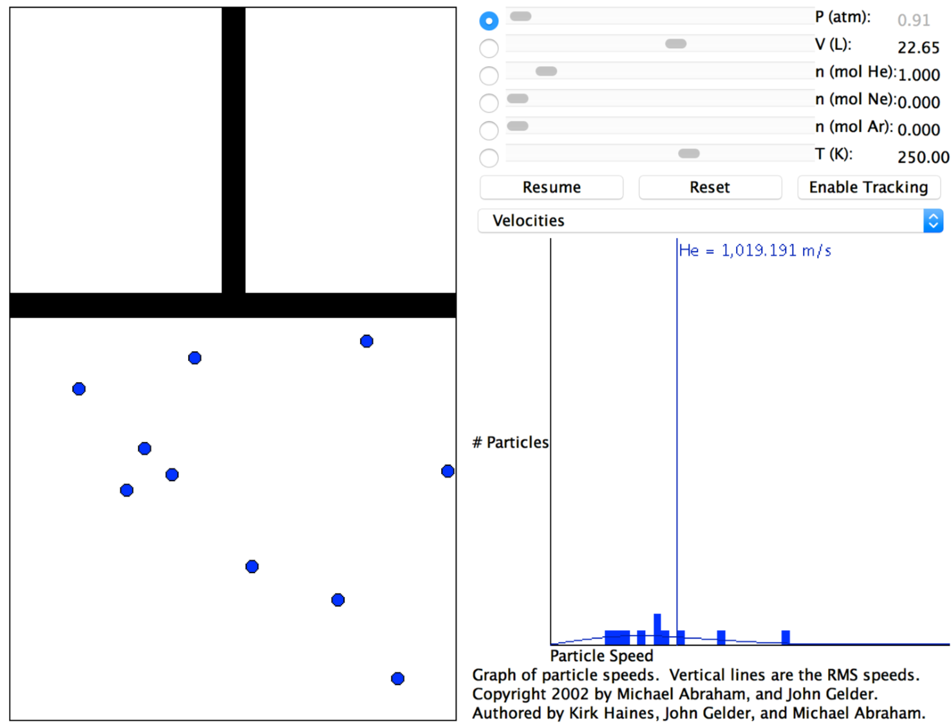
In the above sketch, temperature is 250 K and pressure is 0.91 atm. In the proceeding sketch, the temperature is 400 K and pressure is 1.45 atm.
As indicated, raising temperature raises pressure. Speed distribution in the lower right side, the average speed of the atoms is 1019 m/s.
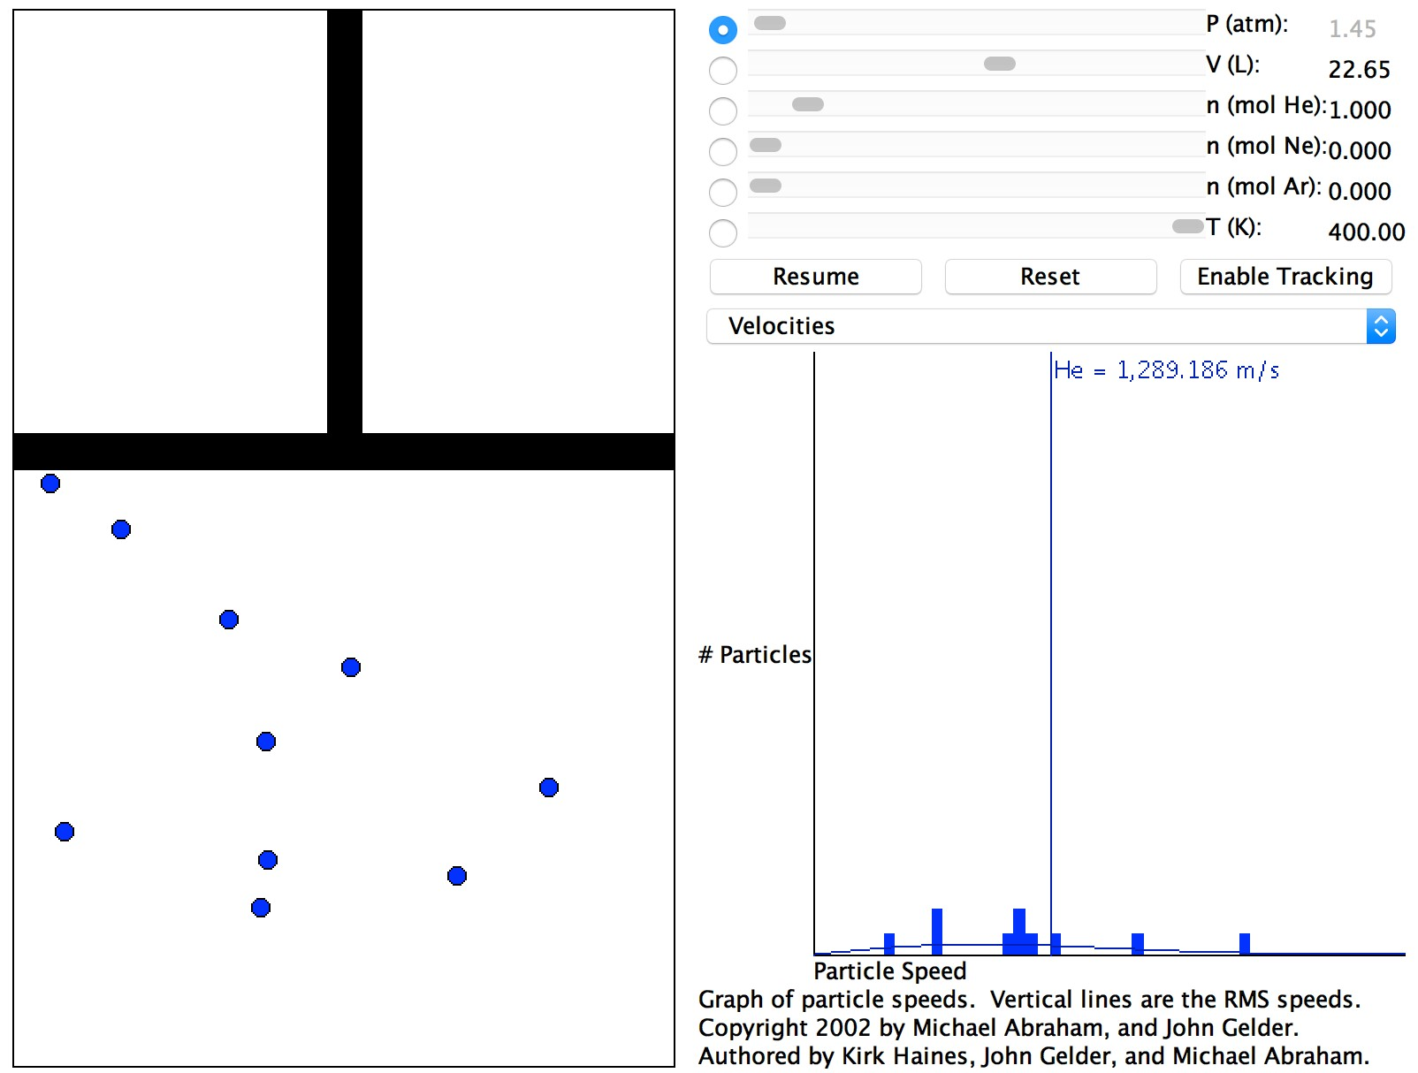
And in this figure, when temperature is higher, the average speed of the atoms id 1289 m/s. The higher speed of the atoms in the container at fixed volume and moles of gas mean that the atoms at 400 K are moving faster hence colliding with the wall more frequently hence exerting much pressure in the container.

  - Using your data, predict the pressure of a gas sample at a temperature of 10 Kelvins. Show how you made your prediction.
From Part II. We concluded that T = 0.0036 K, so if we have a container at the same volume and number of moles of gas as was in the container that we made our measurement in I. F.

P atm. / T = 0.0036 K
P = 0.0036 K ·
10 K= 0.036 atm.

